Logo%20Main%20200

**Boston University**

**Electrical & Computer Engineering**

**EC464 Senior Design Project**

**Final Prototype Test Plan**

*Canine Tracking with SARTopo*

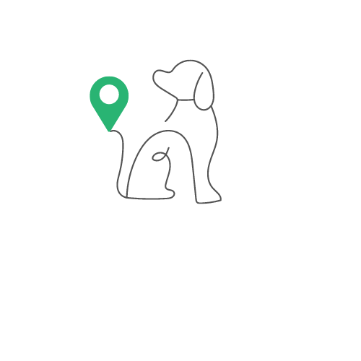

by

Team 17

Team Members

Ragib Ahsan [ragib@bu.edu](mailto:ragib@bu.edu)

Christopher Alonzo [calonzo@bu.edu](mailto:calonzo@bu.edu)

Aanya Kutty [akutty@bu.edu](mailto:akutty@bu.edu)

Ayrton Reulet [reulayrt@bu.edu](mailto:reulayrt@bu.edu)

**Required Materials**

Hardware:

* Teensy 4.1
* Sparkfun Max-M10s GPS Module
* Adafruit ADXL345 Accelerometer
* SMA Antenna
* Flora RGB Neopixel V2
* HC-05 Bluetooth Module
* Rechargeable Battery
* 2 7x9cm double sided PCBs
* 3D printed case
* Android Mobile device

Software:

* Arduino IDE (File already uploaded to Teensy 4.1)
  + Control of accelerometer, LED, GPS Data
* Visual Studio
  + Flutter App
* SARTopo Account
  + Saved SARTopo Map
  + Live Locators
    - Call sign
    - Id

**Set up**

To set up our final test, all hardware wiring will need to be checked and make sure each connection is correct and secure. The PCB board with all the hardware will be placed in the 3D printed case. A connection must be established between the app and the bluetooth module to receive data. The GPS data must have the ability to connect to a satellite. This may be performed by a window or outside depending on weather conditions.

The YCSR app we created must be installed on the Android. Additionally, the SARTopo app will need to be open with a saved map and live locators already in place with unique call signs and IDs. We will demonstrate this for full understanding of the functionality of our app.

**Pre-testing Setup Procedure**

1. Pull all working versions of code from GitHub
2. Correctly wire all components to the Teensy on PCBs
3. Get GPS connection with clear line of view of sky (window)
4. Load YCSR app on Android device
5. Have an instance of SARTopo open with a saved map
6. Create two live locators with unique call signs and IDs

**Testing Procedure**

1. Display 3D case with hardware inside and explain functionality
2. Connect to hardware via bluetooth in the app
3. Demonstrate Live Tracking Page and adding dog information
4. Display live tracking in SARTopo app (Can be on any device)
5. Show conversion of GPS data file to .GPX saved in downloads
6. Upload newly created .GPX file to live SARTopo map
7. Explain remaining steps for GeoFence creation

**Measurable Criteria**

1. LED Turns on
2. Battery successfully powers device
3. Connecting to device via bluetooth
4. Ability to add dog information and save it on the page
5. Accelerometer displaying “Not Sitting or Sitting” live
6. Live tracking of device on a Saved Sartopo Map through our app
7. GPS data successfully converted to .GPX file
8. GPX file uploaded to SARTopo to be analyzed